1.**Requirements.txt**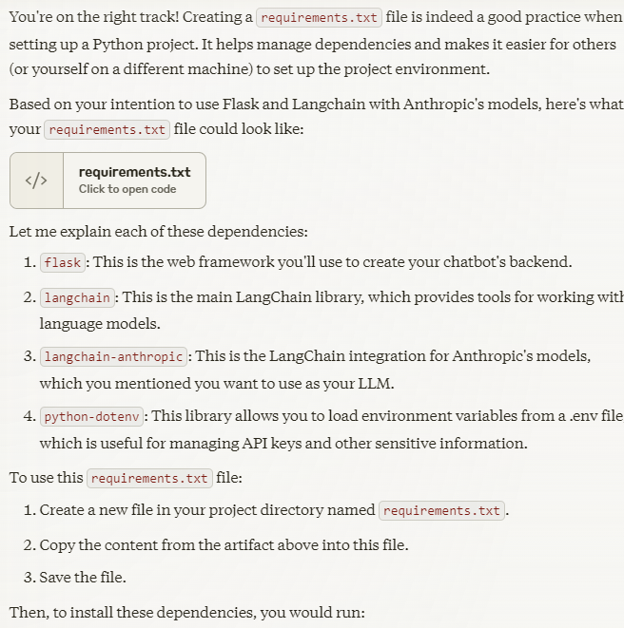

2.**Virtual Env**

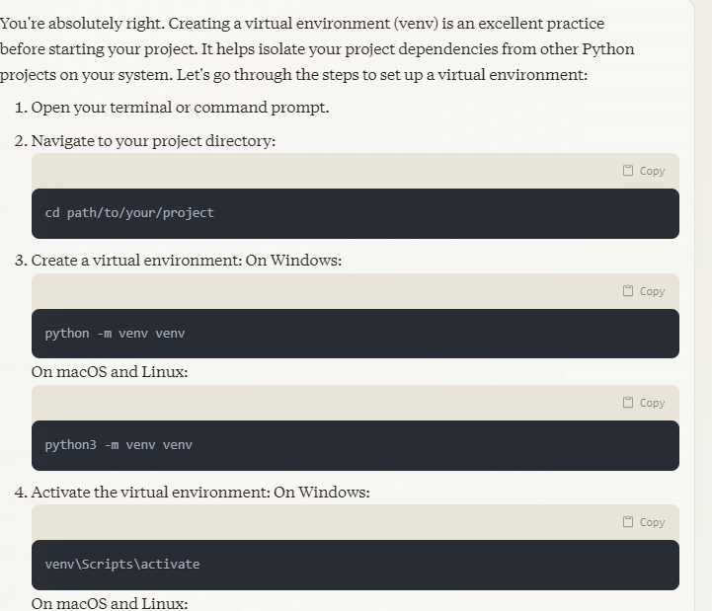

**3.Key Notes-**

**3.1** The code uses Flask, a lightweight web framework for Python.

**3.2** LangChain's ConversationChain is used to manage the conversation flow

**3.3** This chain uses a custom prompt template, the initialized language model, and a memory component to maintain conversation history.

**3.4** 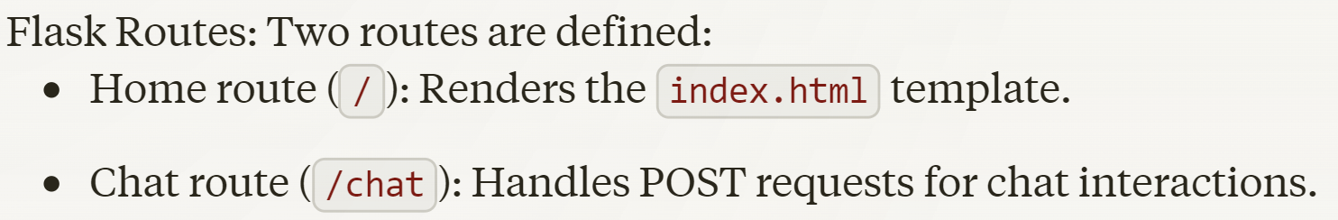

**3.5**

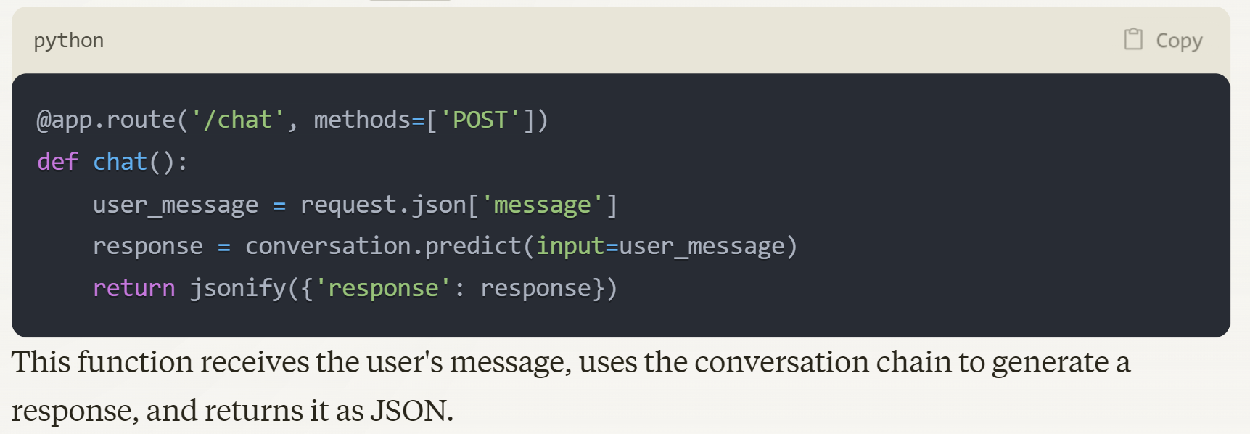

**3.6**

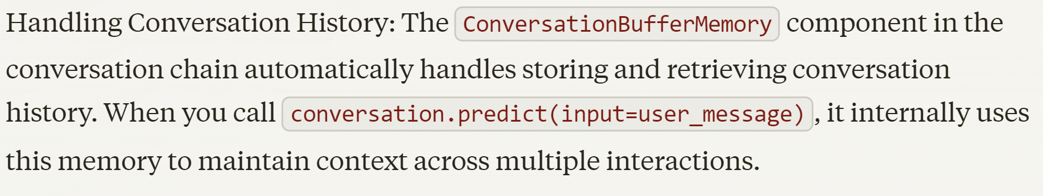

**3.7**